SOFTWARE REQUIREMENTS SPECIFICATION (SRS)
- Introduction
  - Purpose
This document specifies the functional and non-functional requirements of the AI-based Photo Selection Web Application. The system assists photographers and content creators in automatically identifying blurry images, detecting duplicates, and selecting the best pictures captured based on a user-defined number of desired outputs.
1.2 Scope
The system enables photographers or users to upload image folder, perform automated quality analysis, and retrieve a ranked subset of the best pictures. The application focuses mainly on automated selection and does not provide editing or cloud storage services.
  - Definitions
- AI – Artificial Intelligence
- OOM – Object-Oriented Modelling
- ERD – Entity Relationship Diagram
- SRS – Software Requirements Specification

- Overall Description
  - Product Perspective
The system is a web application composed of a client interface, a backend processing system, an AI analysis module, and a persistent database.

2.2 Product Features
- Bulk image upload
- Blur detection and sharpness analysis
- Duplicate detection
- Image ranking and top-Number selection
- Persistent album storage

User Classes

Primary user: Photographer

2.3 Operating Environment
- Web browser
3. Specific Requirements

3.1 Functional Requirements

The system allow users(photographers) to upload multiple images simultaneously.

The system will be able to compute a blur score for each image.

The system should be able compute a sharpness score for each image.

The system would detect and group visually similar images

The system would be able to rank images

The system would allow the user to specify the numbers of desired final images the photographer wants.

The system will be able to return the top ranked images based on how many the photographer want

3.2 Non-Functional Requirements
Performance – The system shall process images within an acceptable response time.
Usability – The interface shall be responsive.
Security – Only authenticated users may access their image albums.

DESIGN CHAPTER
- Introduction to system Design
This chapter presents the design of the AI-based photo selection system. The design is described using object-oriented modelling techniques (OOM) and database modelling principles.
- System Architecture Overview
The system is structured into four major components
  - User Interface
  - Application logic
  - Ai Processing Module
  - Data Storage
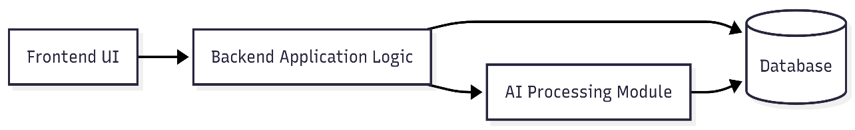Component Diagram
The Above component diagram illustrates the separation of concerns within the system. The frontend handles user interaction, the backend coordinates requests, the AI module performs quality analysis, and the database stores structured information.
- Object-Oriented Model (OOM)
  - Use Case Model
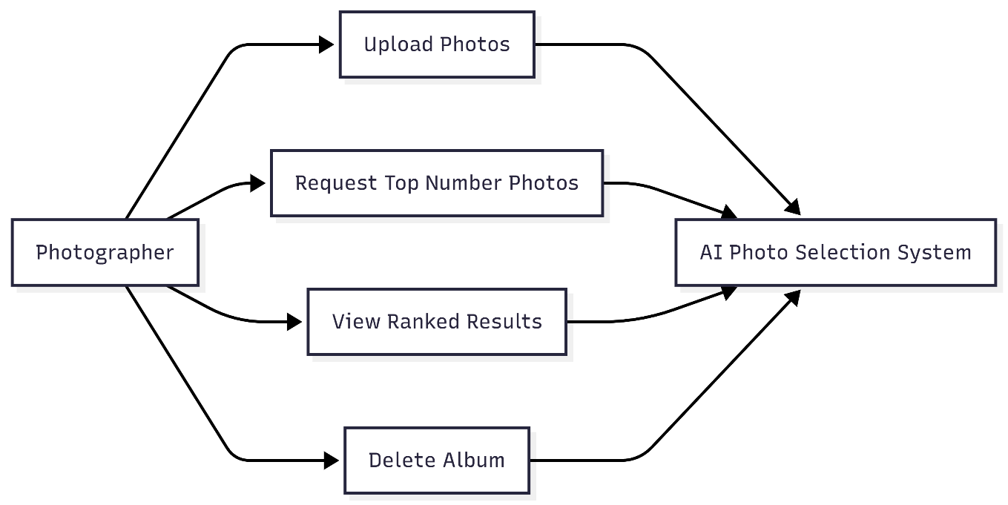
Use case Diagram
The use case diagram presents the interaction between the Photographer and the system. It captures high-level system functionalities including image upload, analysis, and result retrieval.

  - Class Diagram

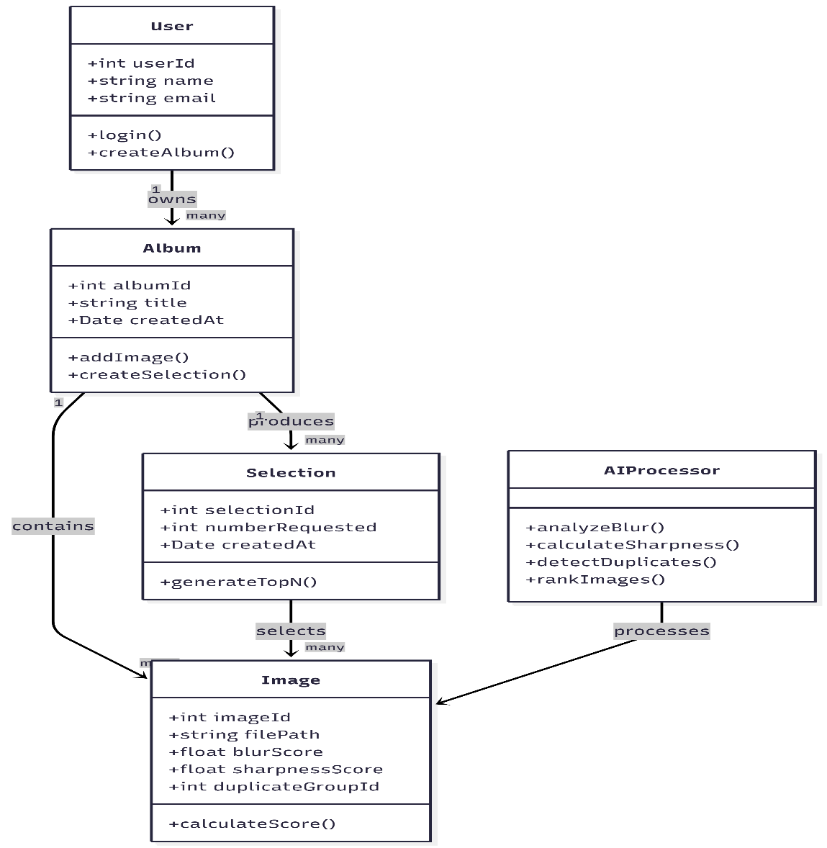
Class Diagram
The class diagram models structure of the system. The classes include User, Album, Image, Selection, and AIProcessor. The associations demonstrate one-to-many relationships between users and albums, and albums and images.

  - Dynamic Behavior
    - Sequence Diagram
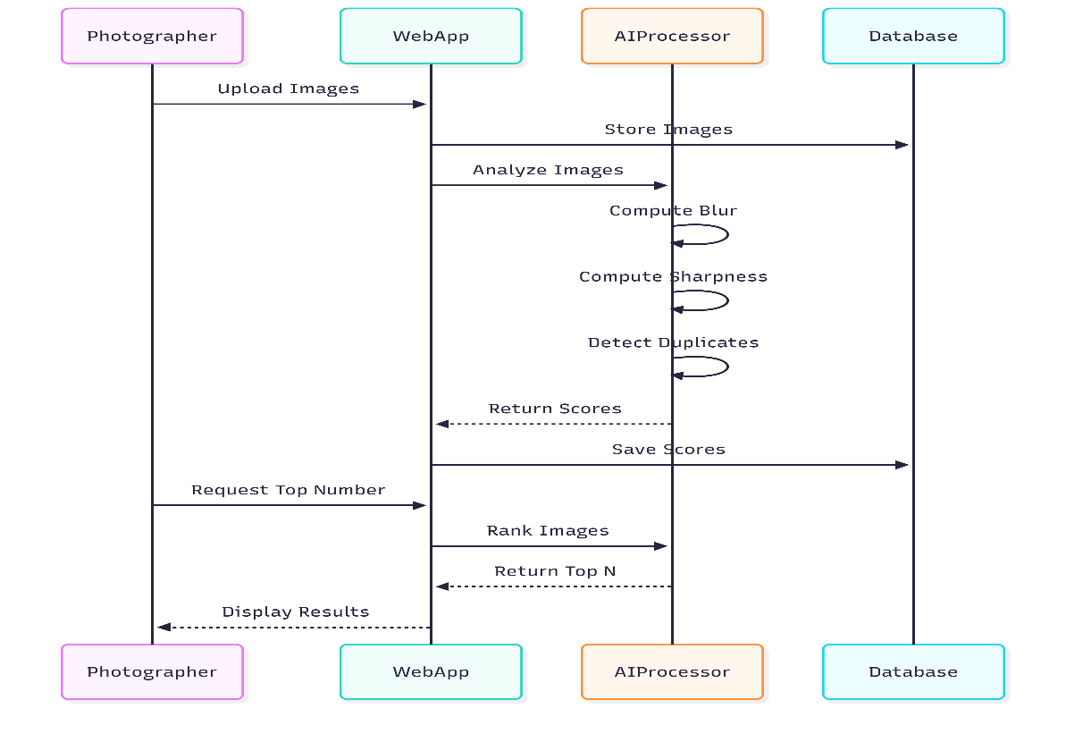
Sequence Diagram
The sequence diagram describes the interaction between system components during image upload and ranking. It models message passing between the web interface, processing logic, AI module, and database.

    - Activity Diagram
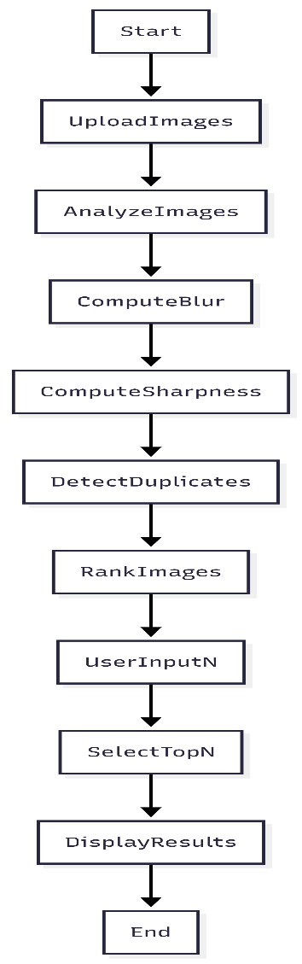
Activity Diagram
The activity diagram represents the logical workflow of the AI-based image selection process, including blur evaluation, duplicate detection, ranking, and final selection.
- Data Structures and Data types
The system relies on structured data representations to manage collection of image and computed scores
- Images are stored in ordered collections.
- Ranking operations rely on ordered data structures.
- Duplicate detection utilizes grouped structures.
- Each image is represented as a structured record containing metadata attributes.
- Database Design
  - Conceptual Model
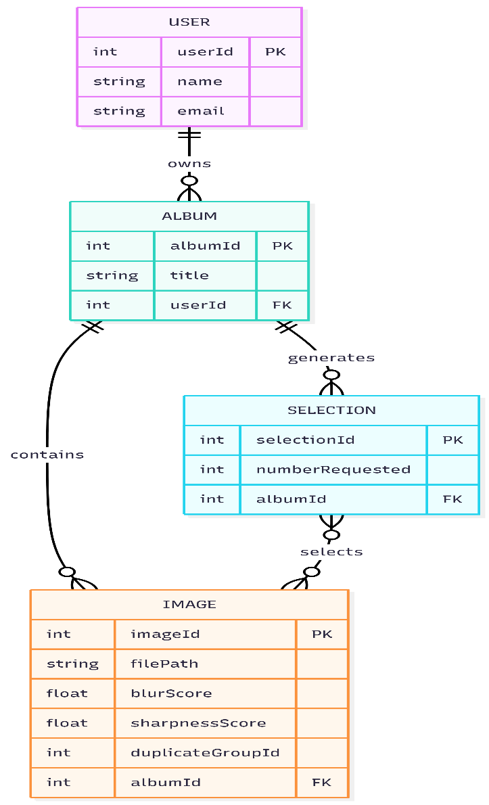

ERD – Entity Relationship Diagram

The ERD defines the relational structure of persistent data storage. Which include User, Album, Image, and Selection. Relationships are defined through foreign key associations.

IMPLEMENTATION CHAPTER
- Technology Stack
The frontend is implemented using a web-based framework. (React.js / Next.js or Angular)
The backend is implemented using a server-side runtime environment.
The AI processing module uses image analysis libraries.
Persistent storage is implemented using a relational database management system.
- Backend Implementation
- Folder structure
- Service layers
- Image processing pipeline
- Ranking logic
- Api Implementation
- Image upload endpoint
- Processing trigger endpoint
- Result retrieval endpoint
- Ai Processing
- Blur detection approach
- Sharpness computation
- Duplicate detection method
- Ranking algorithm

